

**Debre Tabor University**

**Faculty of Technology**

**Department of mechanical engineering**

**Technology Transfer Proposal on:**

**Design solar Disinfected system and experimental testing**

**By:**

**Tadesse Jemal(PI)**

**Kalkidan Nigusa**

**Tamrat degefa**

**Tessafa**

***January , 2020***

Contents

**1. Introduction** 4

1.1 background 7

1.2 Problem statement 9

1.3 Significance 9

1.4. Beneficiaries of the research 9

1.4.1 Direct beneficiaries 9

1.4.2 Indirect beneficiaries 9

1.5 Objective 9

1.5.1 General objective 9

1.5.2 Specific objectives 10

1.6 Scope of the project 10

Chapter Two 11

2.Theoretical Background of the project 11

2.1 SOLAR ENERGY 11

2.1.1 The solar resource 11

2.1.2 Solar technologies 12

2.2 Parabolic Dish Concentrator (PDC) 15

2.3 Compound Parabolic Concentrator (CPC) 16

2.4. Collector type selection 17

2.5 Solar Water Purification System 18

2.5.1 Advantages of solar water disinfection (SoDis) 19

2.5.2 Limitations of solar water disinfection 20

2.6 METHODS OF WATER PURIFICATION 20

CHAPTER THREE 23

3. Literature review 23

CHAPTER FOUR 26

4. Methodology 26

4.1 Methodology 26

4.2 Materials 28

Chapter Five 30

Design and Manufacturing of the Prototype 30

5.2 Components of the Prototype 30

5.3 Installing the Prototype at the Selected Site 34

5.4 EXPERIMENTAL SETUP 35

5.5 Operation Procedure: 38

5.6 TYPES OF WATER QUALITY TESTS 39

5.7 Bacteriological tests 42

Reference 46

Appendix 49

**LIST OF FIGURES**

Figure 2‑1 slanted the sun's rays 12

Figure 2‑2 a} Geometry of parabolic trough b) Parabolic trough concentrator 15

Figure 2‑3 Schematic of parabolic dish concentrator 15

Figure 2‑4 Geometry of compound parabolic concentrator 16

Figure 2‑5 a) Solar stills b) Solar cookers c) Distillers 19

Figure 2‑6 a) Solar stills b) Solar cookers c) Distillers purification system 22

Figure 2‑7 parabolic through collector Figure 2 8 solar purification circuit 22

Figure 4‑1 flow diagram 27

Figure 4-‑2 image of the system 29

Figure 5‑2 parabolic through 32

Figure 5‑3 Parabola calculator value input window 32

Figure 5‑4 parabolic calculator 33

Figure 5‑5 Rolling the metal frame in to parabola curve 33

Figure 5‑6 image of parabolic through components 34

Figure 5‑‑7 Assemble parabolic through 34

Figure 5‑8 installation of parabolic through 35

Figure 5‑9 purification system 36

Figure 5‑10 temperature vs time graph 39

Figure 5‑‑11 image turbidity test of surface water a) before solar heating b) after solar heating 41

Figure 5‑12image PH and ATC test a) before solar heating b) after solar heating 41

Figure 5‑13 image Ammonia test a) prepare reagent ammonia b) Ammonia concentration 42

Figure 5‑14 image a) adjusted 18-hour b) preparation of water on microorganism test 43

Figure 5‑15 Photo a) Surface water before solar heating b) surface water after solar heating 44

**LIST OF TABLE**

Table 4‑1 parametric and dimension of parabolic through 37

Table 5‑2 physical and chemical composition of water before and after solar heating 45

Table A‑1 experimental test water temperature on solar parabolic through 51

Table A‑2 experimental test water temperature on solar parabolic through 52

# **ABSTRACT**

**Water disinfection** means the removal, deactivation or killing of pathogenic microorganisms. Microorganisms are destroyed or deactivated, resulting in termination of growth and reproduction. When microorganisms are not removed from drinking **water**, drinking **water** usage will cause people to fall ill. There is Lack of readily available water in Ethiopia which leads to usage of water directly from the dug well. But the water has a content of micro-organisms and other organisms that will be dangers for health, so it does need purification system. This system will contribute to the overall health and quality of life of those who lack clean drinking water resources. Utilizing solar parabolic trough designs, concentrated solar power is used in order to solve the above problem One method for **solar water** disinfection (also called SoDis) uses **solar** energy to make **water** contaminated with bacteria, viruses, protozoa and worms safe to drink. **Water** contaminated with non-biological agents such as toxic chemicals or heavy metals require additional steps to make the **water** safe to drink. The locally fabricated parabolic reflector made of Aluminum sheet (which is 0.05m thickness) The parabolic arc was drawn using AutoCAD by applying the equation of parabola the aperture width Wa = 1m, (easy to handle and manufacture i.e. fabricate) and Rim angle D = 900 , resulting length of the focus (f = 0.25 m), and the arc length (1.148m). The fabricated parabolic trough collector uses a rectangular mirror strips, pasted along the arc surface (1.148 m) in a parabolic shape that 40 linearly extend into a trough shape. Solar Tracking System The used mechanism for instantly tracking the sunlight (solar radiation) Tracking sun motion in East-West. The volume of water that disinfected microorganisms at an hour and a day is 7.47liters/h and 59.43 liters/day respectively.

# **CHAPTER ONE**

# **1. Introduction**

## 1.1 background

Water purification is the process of removing undesirable chemicals, biological contaminants, suspended solids and gases from contaminated water. The goal is to produce water fit for a specific purpose. Most water is purified for human consumption (drinking water), but water purification may also be designed for a variety of other purposes, including meeting the requirements of medical, pharmacological, chemical and industrial applications. In general, the methods used include physical processes such as filtration, sedimentation and distillation, biological processes such as slow sand filters or biologically active carbon, chemical processes such as flocculation and chlorination and the use of electromagnetic radiation such as ultraviolet light. The purification process of water may reduce the concentration of particulate matter including suspended particles, parasites, bacteria, algae, viruses, fungi; and a range of dissolved and particulate material derived from the surfaces that water may have made contact with after falling as rain.

The world’s total volume of water on Earth is estimated at 1.4 billion km3. Among it, the total freshwater reserves take up only about 2.5% (i.e., 35 million km3). The remaining 97.5% is in the form of saltwater in the oceans and saline groundwater. Freshwater from lakes and rivers, acting as the main sources of human water consumption, only contains an average of about 90,000 km3 of water and just 0.26% of the total global freshwater resources [1]. Global demand for water has increased up to three times with the surge of the population since the 1950s, while the supply of fresh water has been continuously declining [2]. In the future, water resources will encounter crisis conditions because of energy production. About one out of seven people in the world cannot obtain either energy or clean water [3].water has been in existence since the evolution of man. Pumping plays a very pivotal role in the day to day existence of mankind and as a result, different methods have evolved over the years to pump or displace water. Water supply has been a very critical issue, mostly affecting the rural areas. Water is one of nature’s most important gifts to mankind. It is one of the most essential elements to good health and as such, it should be readily available to everybody. To address this problem, different methods and techniques have been used over the years ranging from man-powered operated ones down to the more efficient one. There is evidence around the world of early peoples using pipes and ditches for moving water to where people lived. They were also digging deep wells and making dams to collect and store water [1].

Waterborne pathogens in developing countries cause several billion cases of disease and up to 10 million deaths each year, at least half of which are children. In the rural areas of developing countries, boiling is the means most often used for purifying water for food preparation and drinking. However, boiling is relatively expensive, consumes substantial amounts of fossil en-ergy and the associated wood gathering contributes to depletion of forests.

The decreasing availability of water has necessitated in the search for clean sources of drinking water. There are many processes available for purification of drinking water like Chlorine tablets, Pot chlorination of wells, Slow and rapid sand filters, Fluoride removal, Reverse osmosis plants, etc. In this project, we are making a water purifier which works on solar energy. We are using solar energy which is a renewable source, abundant and cheap. In case of power failures, this purifier will continue to work as solar energy can be stored. This purifier can be used in remote and rural areas where there is no electricity. It provides pollution free operation [2].

There are two main types of solar water pasteurization systems: batch and continuous flow. Batch systems usually consist of a simple refillable vessel. It usually takes a full day of sun for a batch system to treat water (Andreatta et al., 1994; Ciochetti and Metcalf, 1984). In a continuous flow system water flows through a solar collector that heats the water to a desired temperature. A thermostatic valve is commonly used to control temperature and flow. Heat exchangers are often used to preheat untreated water. Fig. 1 shows the schematic of a typical continuous flow solar water pasteurization system. Several researchers have experimented with continuous flow solar water pasteurization systems. Many different methods are used to report system performance. Often the production is given in l/h-m2 or l/m2 -day. Unfortunately there is no direct way to determine daily production from hourly production. Most systems have significant thermal mass so hourly production increases throughout the day as the system warms up.

The purification process of water may reduce the concentration of particulate matter including suspended particles, parasites, bacteria, algae, viruses, fungi; and a range of dissolved and particulate material derived from the surfaces that water may have made contact with while it is still under ground. The standards for drinking water quality are typically set by governments or by international standards. These standards will typically set minimum and maximum concentrations of contaminants for the use that is to be made of the water [3].

## 1.2 Problem statement

Shortage of clean drinking water is a great concern in Ethiopia. As only 42% of the population has access to a clean water supply. Around 70% of our country has a resource of underground water. Yet there is no convenient means that allows the people to have access to this resource.

There is Lack of readily available water in Ethiopia which leads to usage of water directly from the dug well. But the water has a content of micro-organisms and other organisms that will be dangers for health, so it does need purification system. This system will contribute to the overall health and quality of life of those who lack clean drinking water resources. Utilizing solar parabolic trough designs, concentrated solar power is used in order to solve the above problem

## 1.3 Significance

* It can provide a cost-efficient solution
* The solar purification system uses renewable energy source which is efficient
* Solar purification system does not require a large and costly infrastructure
* Its operation and maintenance are very simple

## 1.4. Beneficiaries of the research

### 1.4.1 Direct beneficiaries

* The local Community (People residing in areas) where there is lack of access to clean drinking water

### 1.4.2 Indirect beneficiaries

* Governmental organizations
* Researchers

## 1.5 Objective

### 1.5.1 General objective

The main objective is design and manufacture solar purification system for the selected area.

### 1.5.2 Specific objectives

* Investigate relevant data for the selected area
* Designing solar water purification system
* Manufacturing the assembled purification system
* Testing microorganism in the surface water

## 1.6 Scope of the project

The scope of this project is performing the Design and manufacturing of the solar purification system for the selected area.

# **Chapter Two**

# **2.Theoretical Background of the project**

## 2.1 SOLAR ENERGY

Solar energy can be a major source of power. Its potential is 178 billion MW which is about 20,000 times the world’s demand. But it cannot be developed on large scale. Sun’s energy can be utilized as thermal and photovoltaics’ solar power where sun hits atmosphere is 1017 watts, whereas the solar power on earth’s surface is 1016 watts. The total world – wide power demand of all needs of civilization is 1013 watts. Therefore, the sun gives us 1000 times more power than we need. The energy radiated by the sun on a bright sunny day is approximately 1kw/m2 , which may be used in driving the prime movers for the purpose of generation of electrical energy. Some applications of solar energy are solar water heater, solar cookers, Solar furnaces, Solar ponds, Solar energy collectors, Solar energy storage etc.[9-11]

### 2.1.1 The solar resource

Solar radiation, often called the solar resource, is a general term for the electromagnetic radiation emitted by the sun. Solar radiation can be captured and turned into useful forms of energy, such as heat and electricity, using a variety of technologies. However, the technical feasibility and economical operation of these technologies at a specific location depends on the available solar resource. Every location on Earth receives sunlight at least part of the year. The amount of solar radiation that reaches any one spot on the Earth's surface varies according to:

• Geographic location

• Time of day

• Season

• Local landscape

• Local weather

Because the Earth is round, the sun strikes the surface at different angles, ranging from 0° (just above the horizon) to 90° (directly overhead). When the sun's rays are vertical, the Earth's surface gets all the energy possible. The more slanted the sun's rays are, the longer they travel through the atmosphere, becoming more scattered and diffuse. Because the Earth is round, the frigid Polar Regions never get high energy from the sun, and because of the tilted axis of rotation, these areas receive no sun at all during part of the year.[2] From the rays of the sun, which pass through the earth’s atmosphere to the ground, a portion is scattered by particles or clouds. The intensity of solar radiation outside the atmosphere is about 1.3 kW/m². Even though only a fraction of this actually hits the earth’s surface, the magnitude of the energy from this source is enormous. For example, utilizing only 1% of the earth’s deserts and applying a conversion efficiency of 15% to produce electric energy would develop more

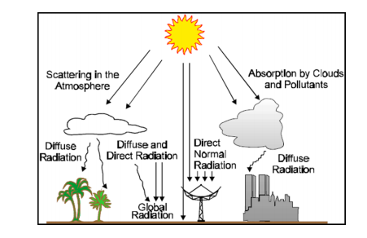

Figure 2‑1 slanted the sun's rays[5]

### **2.1.2 Solar technologies**

Different solar energy collectors may be used in order to convert solar energy to thermal energy. In most of them, a fluid is heated by the solar radiation as it circulates along the solar collector through an absorber pipe. This heat transfer fluid is usually water or synthetic oil. The fluid heated at the solar collector field may be either stored at an insulated tank or used to heat another thermal storage medium. The solar collector may be a static or sun tracking device. The second ones may have one or two axes of sun tracking. Otherwise, with respect to solar concentration, solar collectors are already commercially available; nevertheless, many collector improvements and advanced solar technologies are being developed. The main solar collectors suitable for seawater and brackish distillation are as follow.

**1 Flat-plate collector**

Flat-plate collectors (FPCs) are used as heat transfer fluid, which circulates through absorber pipes made of copper. The absorber pipes are assembled on a flat plate and they usually have a transparent protective surface in order to minimize heat losses. They may have different selective coatings to reduce heat losses and to increase radiation absorption. Thus, the thermal efficiency increases although the collector cost also increases. A typical flat-plate collector is an insulated metal box with a glass or plastic cover and a dark colored absorber plate. The flow tubes can be routed in parallel or in a serpentine pattern. Flat plate collectors have not been found as a useful technology for desalination [10,11]. Although they have been used for relatively small, desalinated water production volumes, production of large volumes of water would require an additional energy source, for example, a desalination facility in Mexico derives energy from flat plate collectors and parabolic troughs [12].

**2. Evacuated tube collector**

Heat losses are minimized in evacuated tube collectors (ETCs) by an evacuated cover of the receiver. This cover is tubular and made of glass. In addition, a selective coating of the receiver minimizes the losses due to infrared radiation. There are two different technologies of evacuated tubes: (1) Dewar tubes two coaxial tubes made of glass, which are sealed each other at both ends; and (2) ETC with a metallic receiver, which requires a glass to metal seal. There are different designs depending on the shape of the receiver. ETCs are set in conjunction with reflective surfaces: a flat-plate or a low-concentrate reflective surface as a compound parabolic one. Usually a number of evacuated tubes are assembled together to form a collector. Evacuated tube collectors require more sophisticated manufacturing facilities than flat-plate collectors. With evacuated tube collectors, higher temperatures can be reached and efficiencies tend also to be higher. For the most part, however, evacuated tube collectors are preferred to flat plate collectors. Also, since evacuated tube collectors produce temperatures of up to 200oC, they are particularly suited as an energy source for high temperature distillation [10].An evacuated-tube collector generally consists of a fluid-filled absorber tube surrounded by a vacuum. 2.2.4 Concentrating Solar Power Concentration of solar energy is one way to improve the thermal efficiency of a system, and increase the production rate of freshwater.

3 Concentration of solar radiation is achieved by the reflection of the flux incident on an aperture area (typically mirror or other reflective surface) onto a smaller receiver/absorber area. 2.2.4.1

**3. Parabolic Trough Concentrator (PTC)**

A parabolic trough is a linear collector with a parabolic cross-section. Its reflective surface concentrates sunlight onto a receiver tube located along the trough’s focal line, heating the heat transfer fluid in the tube as shown in Figure 2.2& 2.3. Parabolic troughs typically have concentration ratios of 10 to 100, leading to operating temperatures of 100–400oC. Parabolic trough collectors (PTCs) require sun tracking along one and/or two axis only. In this way, the receiver tube can achieve a much higher temperature than flat-plate or evacuated-tube collectors. The parabolic trough collector systems usually include a mechanical control system that keeps the trough reflector pointed at the sun throughout the day. Parabolic trough concentrating systems can provide hot water and steam and are generally used in commercial and industrial applications. Still, among solar thermal technologies, solar ponds and parabolic troughs are the most frequently used for desalination. Due to the high temperatures parabolic troughs are capable of producing high-grade thermal energy that is generally used for electricity generation [10]. Parabolic troughs could be a suitable energy supply for most desalination methods, but in practice, have mainly been used for thermal distillation as these methods can take advantage of both the heat and electricity troughs produce. Other methods of desalination would receive little or no benefit from the heat produced. The unit cost of these solar thermal energy production methods directly increases with the temperatures they can yield. As such, flat plate collectors and solar ponds are the least expensive of these on a unit basis and parabolic troughs are the most expensive.

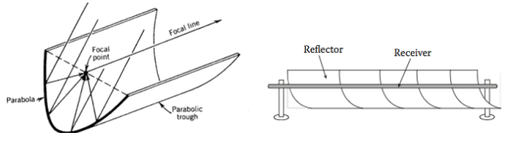

a b

Figure 2‑2 a) Geometry of parabolic trough b) Parabolic trough concentrator[10]

## 2.2 Parabolic Dish Concentrator (PDC)

A parabolic dish concentrator, shown schematically in Figure 2.4, is a point-focus collector that tracks the sun in two axes, concentrating solar energy onto a receiver located at the focal point of the dish. It is at this precise location where maximum thermal efficiency and maximum temperatures are achieved. The maximum temperature achieved is the highest of all concentrators – approximately 600ºC.The advantages of this system include high efficiency, as they are always pointing at the sun; high concentration ratios in the range of 600-2000 suns; and modular collector and receiver units that can function independently or as part of a larger system of dishes, allowing for system scalability [15].

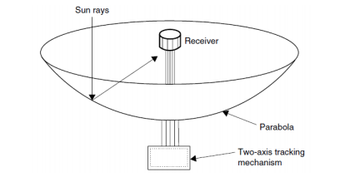

Figure 2‑3 Schematic of parabolic dish concentrator[15]

## 2.3 Compound Parabolic Concentrator (CPC)

A more sophisticated version of the parabolic trough is the compound parabolic concentrator (CPC), which is designed using a rotated parabolic shape. This concentrator is noteworthy for its stationary design – avoiding the need for solar tracking. They are commonly used for solar concentration, and are just starting to be used for desalination applications. The CPCs are disadvantageous for their low concentration ratios (generally 6-10 suns) and low temperatures achieved (on the order of 120ºC). A diagram of a CPC is shown in

r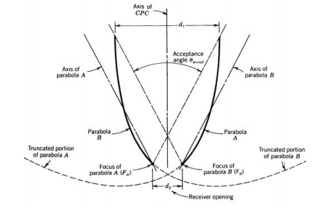

Figure 2‑4 Geometry of compound parabolic concentrator[16]

Solar collector design from the many types of solar collectors developed, three types merit further consideration for steam generation: the parabolic-trough collector (PTC), the compound parabolic collector (CPC) and the flat-plate collector (FPC). The rest one is a tracking collector, whereas the last two are stationary. PTCs are generally of medium concentration ratio (15±40) whereas CPCs are generally of low concentration ratios (1.5±5). The low concentration-ratios of the latter allow them to work without a need for tracking of the Sun.

## 2.4. Collector type selection

In general, concentrating collectors exhibit certain advantages as compared with the conventional at-plate type. The main ones are:

1. The working fluid can achieve higher temperatures in a concentrator system when compared with at-plate system of the same solar-energy collecting surface. This means that a higher thermodynamic efficiency can be achieved.

2. It is possible with a concentrator system, to achieve a thermodynamic match between temperature level and task. The task may be to operate thermionic, thermodynamic, or other higher-temperature devices.

3. The thermal efficiency is greater because of the small heat-loss area relative to the receiver area.

4. Reacting surfaces require less material and are structurally simpler than at plate collectors. For a concentrating collector, the cost per unit area of the solar collecting surface is therefore less than that of a flat-plate collector.

5. Owing to the relatively small area of receiver per unit of collected solar energy, selective surface treatment and vacuum insulation to reduce heat losses and improve the collector efficiency are often economically viable.

Their disadvantages are:

1. Concentrator systems collect little diffuse radiation, the rate depending on the concentration ratio.

2. Some form of tracking system is required, so as to enable the collector to follow the Sun.

3. Solar-collecting surfaces may lose their receptance with time and may require periodic cleaning and refurbishing

## 2.5 Solar Water Purification System

One method for **solar water** disinfection (also called SoDis) uses **solar** energy to make **water** contaminated with bacteria, viruses, protozoa and worms safe to drink. **Water** contaminated with non-biological agents such as toxic chemicals or heavy metals require additional steps to make the **water** safe to drink.

**Sources of water**

**Groundwater**: The water emerging from deep ground water may have fallen as rain many tens, hundreds, thousands or in some cases millions of years ago. Soil and rock layers naturally filter the ground water to a high degree of clarity before it is pumped to the treatment plant. Such water may emerge as springs, artesian springs, or may be extracted from bore holes or wells. Deep ground water is generally of very high bacteriological quality (i.e., pathogenic bacteria or the pathogenic protozoa are typically absent), but the water typically is rich in dissolved solids (TDS).

**Upland lakes and reservoirs:** Typically located in the headwaters of river systems, upland reservoirs are usually sited above any human habitation and may be surrounded by a protective zone to restrict the opportunities for contamination. Bacteria and pathogen levels are usually low, but some bacteria, algae and protozoa might be present.

**Rivers, canals and low-land reservoirs:** Low-land surface waters have a significant bacterial load and may also contain algae, suspended solids and a variety of dissolved constituents.

**Atmospheric water generation**: it is a new technology that can provide high quality drinking water by extracting water from the air by cooling the air and thus condensing water vapor.

**Rainwater harvesting** or fog collection which collects water from the atmosphere can be used especially in areas with significant dry seasons and in areas which experience fog even when there is little rain. Desalination of seawater by distillation or reverse osmosis.

**Solar stills**: A solar still is a low-tech way of distilling water, powered by the heat of the sun. Two basic types of solar stills are box, and pit. In a solar still, impure water is contained outside the collector, where it is evaporated by the sun through clear plastic. The pure water vapor (and any other included volatile solvent) condenses on the cool inside plastic surface and drips down off the low point (pebble), where it is collected and removed. The box type is more sophisticated. Solar cookers: A solar cooker is a device which uses sunlight as its energy source. Because they use no fuel and they cost nothing to run, humanitarian organizations are promoting their use worldwide to help slow deforestation and decertification, caused by using wood as fuel for cooking.

**Solar cookers** are also sometimes used in outdoor cooking, especially in situations where minimum fuel consumption or fire risk is considered highly important.

**Distillers**: A distiller is a device which uses electricity to boil water and condense it to give pure distilled water. It is not widely use because it has a high running cost as large amount of energy is required to boil water.

**Solar distiller**: There has been a lot of research and experimentation on solar distils. These use energies from the sun to evaporate water at normal temperatures. There are many drawbacks in the design. The cost of manufacturing or construction is very high. The water is not boiled hence bacterial and other organisms in water may not perish. The extensive number of parts can lead to errors and leaks which might result in impure water. The whole process takes longer time then boiling.

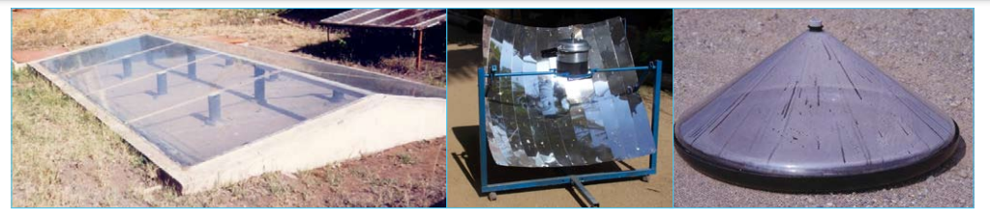

**a b c**

Figure 2‑5 a) Solar stills b) Solar cookers c) Distillers

### **2.5.1 Advantages of solar water disinfection (SoDis)**

* SODIS improves the microbiological quality of drinking wate
* SODIS improves the family health.
* SODIS can serve as an entry point for health and hygiene education.
* Public water supply systems in developing countries often fail to provide water safe for consumption. SODIS provides individual users a simple method that can be applied at household level under their own control and responsibility.
* SODIS is easy to understand.
* Everybody can afford SODIS, as the only resources required are sunlight, which is cost free and plastic bottles.
* SODIS does not require a large and costly infrastructure and therefore easily is replicable in self-help projects.
* SODIS reduces the need for traditional energy sources such as firewood and kerosene/gas.
* Consequently, the use of SODIS reduces deforestation, a major environmental problem in most developing countries, and SODIS decreases air pollution created by burning conventional energy sources.
* Women and children often spend much of their time and energy collecting firewood. SODIS reduces this workload as less firewood needs to be collected.
* Financial advantages: Household expenditures can be reduced when the user’s family health is improved: fewer financial resources are required for medical care. In addition, expenses for traditional energy sources such as gas, kerosene and firewood are reduced. Only limited resources are required for the procurement of transparent plastic bottles. Therefore, even the poorest can afford SODIS.

### **2.5.2 Limitations of solar water disinfection**

* SODIS requires sufficient solar radiation. Therefore, it depends on the weather and climatic conditions.
* SODIS requires clear water.
* SODIS does not change the chemical water quality.
* SODIS is not useful to treat large volumes of water.

## 2.6 METHODS OF WATER PURIFICATION

The major task of water purification is to protect the public water environment and public health by removing biological and chemical materials from the water Treatments for Algal Blooms Salvage Since 2007, algal salvage has become a routine of the local government to dispose of the algal bloom from April to October each year.

* Flocculation
* Utilizing the Food-chain
* Membrane Filtration
* Treatments to Hypoxia
* Aeration

Solar Disinfection Solar disinfection (SODIS) was developed in the 1980s to inexpensively disinfect water used for oral rehydration solutions. In 1991, the Swiss Federal Institute for Environmental Science and Technology began to investigate and implement SODIS as a household water treatment option to prevent diarrhea in developing countries. Users of SODIS fill 0.3-2.0-liter plastic soda bottles with low-turbidity water, shake them to oxygenate, and place the bottles on a roof or rack for 6 hours (if sunny) or 2 days (if cloudy). The combined effects of UV-induced DNA alteration, thermal inactivation, and photo-oxidative destruction inactivate disease-causing organisms. Lab Effectiveness, Field Effectiveness, and Health Impact In the laboratory, SODIS has been proven to inactivate the viruses, bacteria, and protozoa that cause diarrheal diseases. Field data have also shown reductions of bacteria in water from developing countries treated with SODIS. In four randomized, controlled trials, SODIS has resulted in reductions in diarrheal disease incidence ranging from 9- 86%.

Benefits, Drawbacks, and Appropriateness

The benefits of solar disinfection are:

* Proven reduction of viruses, bacteria, and protozoa in water Proven
* reduction of diarrheal disease incidence Simplicity of use and acceptability
* No cost if using recycled plastic bottles Minimal change in taste of the water
* Recontamination is served and stored in the small narrow necked bottles

The drawbacks of solar disinfection are:

* Need to pretreat water of higher turbidity with flocculation and/or filtration
* Limited volume of water can be treated at once
* Length of time required to treat water
* Large supply of intact, clean, suitable plastic bottles require

**Working principles**

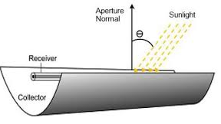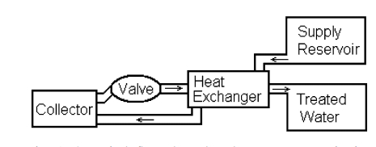

Figure 2‑6 a) Solar stills b) Solar cookers c) Distillers purification system[8]

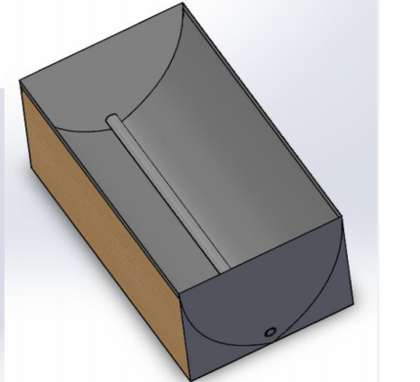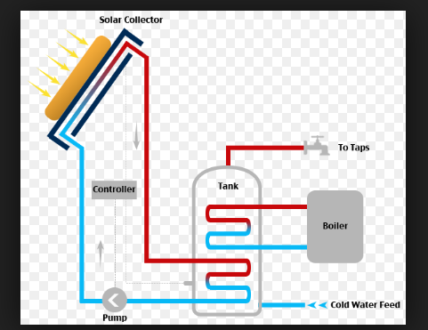

Figure 2‑7 parabolic through collector Figure 2 8 solar purification circuit

Fluid cycle start from feed water tank, water pumped at Tin-exc in inlet water pipe to heat exchanger, water exchange heat with steam leaving heat exchanger at Tout-exc , after that pass through absorption system within the free space between glass envelope at T glass and absorber pipe, to re-enter absorption system in absorber pipe at Tab-in,, leave it at Tab-out , then to separation tank to separate steam from the boiled water, steam exchange heat with inlet water to loss heat for condensation purpose to be distilled water and inlet water gain heat for heating purpose, un vaporized hot water in separation tank will be returned to be mixed with feed water tank.

# **CHAPTER THREE**

# **3. LITERATURE REVIEW**

**Dr. Prakash et al. [2]** As solar energy is being used for the purification of water, which is cheap and abundant, it can be used everywhere where electricity is not available. Here, the microcontroller which is used also prevents the water from overflowing. Moreover, reverse osmosis is a good disinfectant process. This project has only capital cost and almost no running cost.

**Nikhil Jacob Zachariah et al. [3]** Water purification is the removal of contaminants from untreated water to produce drinking water that is pure enough for human consumption. Substances that are removed during the process include parasites, bacteria, algae, viruses, fungi, minerals (including toxic metals such as lead, copper and arsenic), and man-made chemical pollutants. A hand pump is used in a closed system to generate pressure to pass the water through a series of filters and a reverse osmosis membrane to obtain potable water at the outlet. The flow obtained was analyzed using ANSYS and the system delivering highest output was chosen. The project facilitates the availability of pure drinking water.

The purity tests performed on the output from the system showed that there was a large reduction in the concentration of impurities. The output showed increased reduction in concentration of certain impurities compared to commercially available models. The cost comparison with various commercially available products showed that the fabricated model was a cheaper alternative.

What alters our design from the existing ones is that it combines the pedal operated water pumping mechanism with solar purification system. It also gives importance to human ergonomics, time saving, health. It reduces the accidents that can be caused due to open dug wells. Moreover, it is cost effective as it saves foreign currency for it can be manufactured from locally available materials.

**Anderson [4]** used a parabolic trough solar concentrator to pasteurize water. An automotive thermostat-controlled flow. The system had an aperture area of 28 m2 and produced 2500 l/day (89.3 l/m2-day).

Flat plate solar collectors were used by **Jorgensen al. [5]** to pasteurize water. An adjustable thermo-stat valve was used to control flow. The effect of the valve set point on the inactivation of microorganisms was studied. With a set point of 75 0C the collector treated about 50 l/m2-day.

**(Andreatta et al., 1994). Anderson[6]** used a parabolic trough solar concentrator to pasteurize water. An automotive thermostat-controlled flow. The system had an aperture area of 28 m2 and produced 2500 l/day (89.3 l/m2 -day). Flat plate solar collectors were used by **Jorgensen et al. (1998)** to pasteurize water. An adjustable thermostat valve was used to control flow. The effect of the valve set point on the inactivation of microorganisms was studied. With a set point of 75 C the collector treated about 50 l/m2 -day. A flat plate solar water pasteurizer with an integral heat exchanger was designed and tested by

**Stevens et al. [7].** The system-controlled flow with an automotive thermostat and heated water to about 75 C. After a significant warm-up period the system was capable of treating up to 55 l/h-m2 . Safe Water Systems produces a flat plate solar pasteurization system. The system uses a custom designed valve to pasteurize water at a temperature of 79 C. With a heat exchanger and a collector area of 3.7 m2 the system can produce up to 95 l/h during steady state operation and up to 760 l/day [205 l/m2 -day] (SWS, 2002). As an alternative to a thermostat valve, the flow through a collector can be controlled by taking advantage of the thermal expansion of water, as first proposed by Boettcher et al. (1983). In a density driven system water is fed to the system from a fixed height. The water flows through the collector and then must pass through a riser tube that is slightly higher than the feed water reservoir. Flow will not occur unless the water in the riser tube is warm enough. The relative height of the water columns can be adjusted to achieve the desired water treatment temperature.

**Bansal et al. [18**] conducted experiments with density driven water treatment systems. When evacuated tube collectors were used about 10 l of water was produced per kW h of solar radiation (2.8 l/MJ). Flat plate collectors produced about 3.5 l/kW h (0.97 l/MJ). Both systems heated water to about 95 C. Cobb (1998) constructed a simple pasteurization system out of two concentric copper pipes. The temperature in the outer pipe reached 85 C. The maximum flow rate of the system was about 4.2 l/h for a collector area of 0.56 m2 (7.5 l/h-m2 ).

**Both Hunter [17] and Schmidt and Cairncross [19]** suggest that a large fraction of any observed reduction in disease rates in un-blinded household water treatment studies may be attributed to bias (reporter, observer, recall or publication) associated with subjective outcome measures such as self-reporting which has been used in almost all of the SODIS studies [19]. Conducting a randomized, controlled and blinded study of SODIS in developing countries would present significant challenges in any developing world setting with regard to the feasibility of treatment, randomization and distribution of SODIS treated water by third parties independent of the study households. If the care-giver is to be truly unaware of whether the water they are consuming in their household is in the intervention or control groups then a third party is required to administrate the treatment elsewhere and distribute the water to the participating households. Access to a space sufficiently large to expose several hundred 2-L bottles without fear of interference within an urban setting, would be problematic. Since the recommendation is that SODIS water is consumed within 48 h of treatment, this distribution would have to be carried out in such a way that sufficient water was provided to each of the rural or peri-urban households every 2 days – amounting to the treatment and transport of more than 2000 L (2 metric tons – assuming 750 participants) on each occasion. The intervention thus trialled would bear so little relationship to real-life point-of-use water treatment that the external validity of the trial would be questionable. Studies demonstrating post-collection contamination of water reinforce the necessity for household water treatment to occur at the point of use. Anyone who has been involved with field research in the area of household water treatment and storage technologies in the developing world will know that likelihood of successful project completion is extremely sensitive to the simplicity of the trial methodology. The gain in internal validity will necessarily be at the cost of a significant loss of external validity

**Kraemer and Mosler [19]A** survey on the use of SODIS with 878 households in slums of Harare in Zimbabwe conducted and showed that the uptake of SODIS could be determined very well in terms of persuasion research factors such as knowledge, affect, attitude, involvement, convictions (time, money, health), self-efficacy, social influence, and self-persuasion (talking about an innovation self-convinces the person). **Finally, Graf et al. [21]** analyzed hygiene behavior and SODIS uptake in 500 households in the Kibera slum in Nairobi (Kenya). Using factors such as perceived risk, severity, causes of diarrhea, biomedical knowledge, action knowledge, belief in importance of clean water, and social norms, they could accurately explain both SODIS uptake and hygiene behavior.

# **CHAPTER FOUR**

# **4. METHODOLOGY**

## 4.1 Methodology

The methods employed to achieve the objectives of the project are:

• Literature Survey: Books, journals and articles are reviewed in solar technology, performance improvement and the current solar technology for purification system.

• Prototype Design: A prototype of the parabolic trough is designed with some specified dimensions. To simplify the design process, appropriate software is used. The applied software also helps to visualize the prototype before manufacturing.

• Manufacturing prototype: After the design process is completed, the prototype is manufactured. Based on the design parameters and design materials, the prototype of the parabolic trough is manufactured in the Mechanical Engineering Department workshop deberetabor university.

• Installing the Prototype: The prototype of the parabolic trough is installed at a site very close to the Mechanical Engineering Department workshop

• Experimental Investigation: After the prototype is installed, experimental investigation was conducted by recording data.

• Analysis and Interpreting the Result: The test results are compiled and compared with the results obtained using a mathematical model to check the validity of the result.

The following are methods graphical expression to be used to achieve the objectives of the project.

Data collection

* Literature review and previous research works
* Annual solar energy for the selected area

Data analysis

* Modelling parabolic collector and Experimental analysis
* Numerical analysis

Data interpretation

* Using tables
* Graphs,
* diagrams
* and charts

Conclusion

Figure 4‑1 flow diagram

## 4.2 Materials

Locally Fabricated PTC

4.1 Description the fabricated PTC: Locally manufactured small-scale parabolic trough collector is shown schematically in Figure 4.2 and as photo in Figure 4.2, The PTC has been designed, constructed and tested. The model located at yard surrounded by high wall; it is installed East-west direction. The experimental set-up used in this study consisted of the locally fabricated parts of the parabolic trough solar energy concentrator used for heating up the water to evaporation temperature to generate steam for producing distilled water. The designed parabolic trough solar collector for maximum utilization of the solar energy achieved by heating up the water to disinfected microorganisms. Our design to make the system compact therefore the feed water and outlet steam, distilled water at one side of the equipment, resulting no need for thermal insulation material for inlet water line this is due passing it through the free space absorber this installation minimizes heat losses from inlet water line as well as extra heat gain. The Parabolic trough collector frame can be tilted up to 100 to increase the amount of radiation intercepted and reduce reflection and cosine losses, consequently the absorber inner surface will be fully wetted of water to give bubbly flow instead of annular flow, i.e., if the steam formed at down bottom of the absorber this will push all the water in the absorber pipe to be flushed at steam velocity thus losing the hot water to be converted to steam, because required flow is small (2.1-4.8 L/hr) it takes much time to fill the absorber by water, therefore keeping small open of the ball valve to keep storing the hot water as much possible more time for more phase change. Experimental model location at a yard surrounded with high walls to reduce conventional heat losses due wind because it is the major heat loss therefore higher thermal efficiency of the parabolic trough collector, height of the surrounded walls must be too high to avoid solar radiation shadow on the reflector at experiment time.

The locally made parabolic through solar energy concentrator shown as a photo in Figure 4.2 consists of the following components, reflector surface, reflector frame support, absorber pipe, and stands were fabricated using locally sourced materials will be described as follows

Parabolic mirror the locally fabricated parabolic reflector made of Aluminum sheet (which is 0.05m thickness) as shown a photo in Figure 4.4. The parabolic arc was drawn using AutoCAD by applying the equation of parabola = ¸[⁄4: , Assume the aperture width Wa = 1m, (easy to handle

Figure 4‑2 image of the system

and manufacture i.e. fabricate) and Rim angle ¹D = 900 , resulting length of the focus (f = 0.25 m), and the arc length (1.148m). The fabricated parabolic trough collector uses a rectangular mirror strips, pasted along the arc surface (1.148 m) in a parabolic shape that 40 linearly extend into a trough shape. Solar Tracking System The used mechanism for instantly tracking the sunlight (solar radiation) Tracking sun motion in East-West.

# **CHAPTER FIVE**

# **DESIGN AND MANUFACTURING OF THE PROTOTYPE**

## 5.1 Introduction

Production of a parabolic trough prototype is the major work of this project work. The analyses of the test results are dependent on reliable measurements. However, if all the right procedures of design as well as production methods are thoroughly followed, the accuracy of the test will converge to the theoretical expectation. Standard design procedures have been implemented to come up with an accurate design, as much as possible, as discussed below.

manufacturing of the prototype needed a coordinated step that will inferred to the limited recourse available in the work shop of the Mechanical Engineering Department, available machines, work force, both skilled and labor, and consumable materials

## 5.2 Components of the Prototype

### 1. Stand

The stand, four legged, holds all the components up right: parabolic trough support, the ratchet mechanism and tracing mechanism, up from the floor

**2. Trough support**

This part of the parabolic trough connects the lower part of the support to the upper part of the

trough. The parabolic troughs are connected to this support using bearings so that it is free to

rotate from east to west to trace the solar position. This part also gives a rigid structural support

of the trough with the stand

**3. The parabolic trough**

The parabolic trough is the most important part of the assembly. The solar radiation strikes the

surface of the trough reflected to the focal point. The parabolic trough structure is made from

RHS metal and angle iron and the reflecting material is aluminum sheet.

The development of the concentrator takes the maximum effort for the whole efficiency of the

object depends on the capability of the reflector to focus the radiation emanating from the

surface. For the development of the concentrator, first, the size of the parabola is determined. Then its focal point position is evaluated which is accessed from the curve mathematical relation

given as:

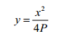 ( 4.1)

where: P is the focal point of the parabola

In Equation (4.1), three unknown variables exist that take the equation to indeterminate state, on

which the number of unknowns exceeds the number of equations. Therefore, at least two of the unknowns should be defined to have the third variable and take out the equation from indeterminate state. To get a better shape of a parabolic curve some interpolations are done to have a better focal point that best sizes the curve. The interpolation is done by varying the value of the focal point (P) for some interval values of x and y-axis. At most, the selection criterion is manufacturability of the parabola in the workshop using the available machines.

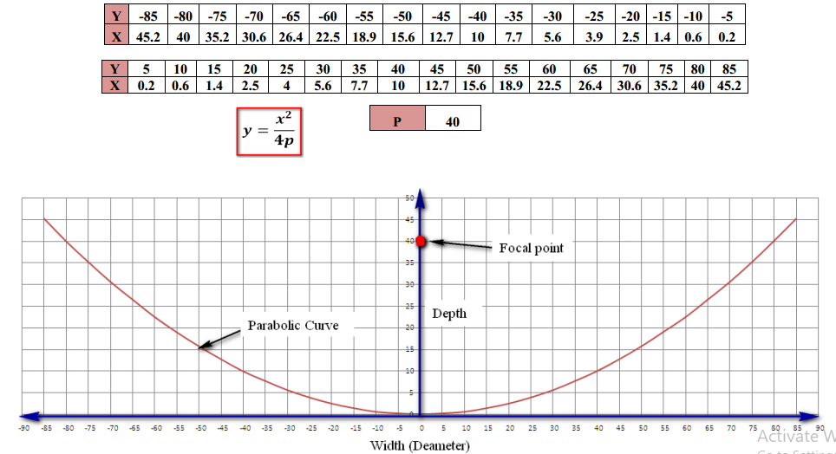

Figure 5‑1 parabolic through

The above iterated results are checked by using Parabola Calculator version 2.0 software. The

software is a Freeware program written to help the designing of solar collector or wifi projects

using parabolic reflectors. Weather improving the signal strength of a wifi antenna, or designing

a satellite antenna or solar trough program calculates the focal length and (x, y) coordinates for a

parabola of any diameter and depth. It can help to determine what size and shape to make a

parabola very quickly.

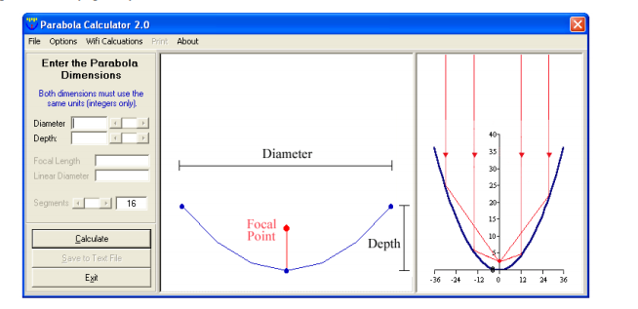

Figure 5‑2 Parabola calculator value input window

On the software interface, values of the parabolic curve diameter and depth are fed, then the

software calculates the values of focal length, volume, linear diameter and area of the parabolic

curve. For this case, from the above iteration the diameter of the parabola is 170 cm and the

depth is 45.2 cm. After feeding these values to the software, the result is the same as the result

that is obtained from the excel iteration

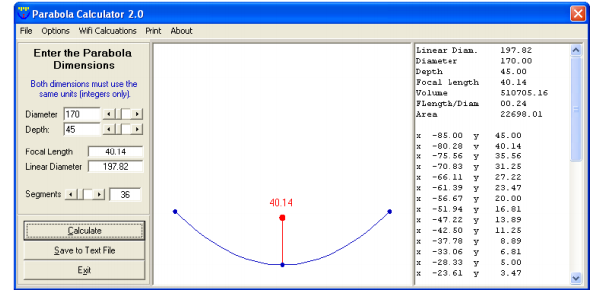

Figure 5‑3 parabolic calculator

After the parabolic curve is obtained, the next step is to manufacture the curve using the RHS

metal frame. First, the RHS metal frame is curved into the obtained parabolic curve, using rolling

machine available in the workshop as shown in the figure below.

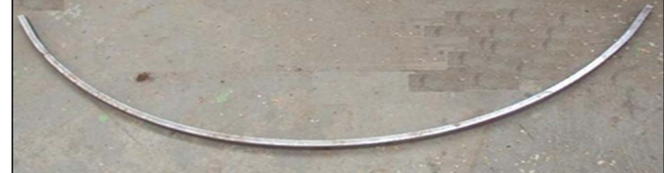

Figure 5‑4 Rolling the metal frame into parabola curve

To make 3.5 m long and 1.7m diameter parabolic trough, 6 curved RHS are used. These 6 curved RHS components are then connected together with angle iron metals, with interval of 1m between them, as shown in Figure.

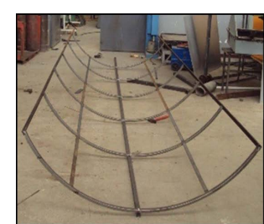

Figure 5‑5 image of parabolic through components

After the structure part is assembled, 2m x 1m x 0.5mm aluminum sheet metals are used to cover

the upper part of the parabolic structure. The aluminum reflector sheets are riveted to the structure

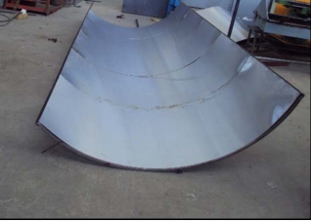

Figure 5‑‑6 Assemble parabolic through

## 5.3 Installing the Prototype at the Selected Site

Before installing the prototype, the appropriate site is selected for the test. The selection criteria were free from shadow and the availability of wide area that would facilitate the testing procedure. The selected site is free from building shadow starting from 3:00 in the morning up to 9:40 in the afternoon. Hence, for eight testing hours the site clear is from any shadow The first work of the installation is to fence the selected site with the appropriate material that would help test the interference and it secures the testing site from any other damages. Prototype without any 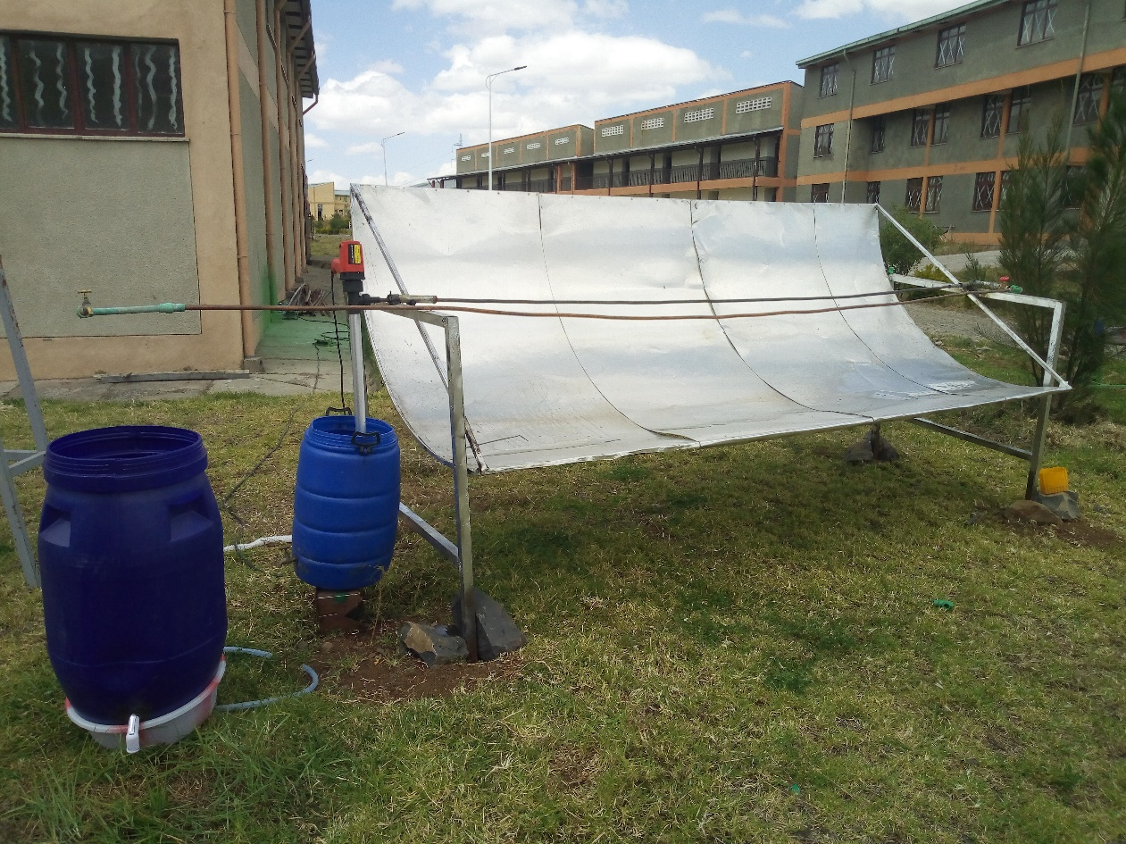

Figure 5‑7 installation of parabolic through

## 5.4 EXPERIMENTAL SETUP

The figures and diagrams show the experimental setup of the parabolic shaped solar water purification, the components parabolic solar frame, two water storage tanks and spirally placed tubes. The water tubes made of copper have been spirally placed over the frame with the holds the tightly to the frame. The tube collects the heat and transfers the heat to the flowing water. The heat water outlet storage tank spray in nozzle condensate of water and out the pure water.

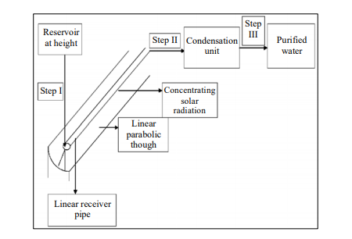

Figure 5‑8 purification system

**Reflector**

Reflector is one of the vital part of the parabolic trough collector as it decides the fraction of solar irradiance to be collected by the absorber tube. A parabolic reflector reflects and concentrates all the sun rays on the absorber tube. The Reflector is a parabolic shaped mild steel sheet (2mm thick coating nickel chrome) .rim angle 90°.

**Absorber Tube**

The absorber tube is placed at the focal length of the parabolic trough collector. The outer diameter and inner diameter of absorber tube are 0.015m and 0.013m respectively along with a length of 0.970m. The solar radiations reflected by the parabolic trough collector are collected by the absorber tube. Water is used as working fluid in the copper tube absorber tube.

EXPERIMENTAL SETUP

The experimental setup used for testing the locally manufactured parabolic trough collector is shown schematically in Figure and. It consists of the following:

1. Constructed wooden frame of width 100 cm, and Length 350 cm.

2. Parabolic Reflector made from a mirror strips of Aluminum sheet 350 cm × 100 cm

3. Construct Two stands, which hold parabolic through with fixed length,

4. Absorptance system; consists of absorber copper pipe painted black with external diameter, inlet water copper pipe with external diameter ɸ0.15” .

5. Condensing pipe made of stainless-steel pipe ɸ20”, with length 3 m.

6. Two Jars; one for feed water, and the second distilled water.

7. Solar Radiation Tracking System; control the parabolic trough collector frame in east-west directions by make hole on the stand and parabolic trough holder due to the direction of sun and hold it using bolt through two holes.

Table 4‑1 parametric and dimension of parabolic through

|  |  |
| --- | --- |
| Collecter Aperture | 1m |
| Collector Length | 3.5m |
| Parabolic curveture | 1.14m |
| Rim angle | 90degree |
| Focal distance | 0.25m |
| Reciever external diameter | 12mm |
| Inlet pipe diameter | 20mm |
| Inlet pipe material | Galvanized steel pipe |
| Inlet pipe thermal coductivity | 385w/m2 |
| Absorber material | Copper |
| Absorber thermal conductivity | 385w/m2 |
| Instalation direction | West-east |
| Tracking mechanism | Manual with adjustables holes |
| Tilt angle | 12degree |
| Temperature device measurement | Inferand thermometer |
| Measured temperature | Ambient temerature and outlet temperature |

## 5.5 Operation Procedure:

The following steps to be followed before starting the experiment, during the experiment, and after finishing the experiment as follow:

1. Cleaning the reflector (from the accumulated dusts or dirt’s this can be achieved

2. Fill the jar of feed water by surface water.

3. Check if there are damaged parts

4. Regulating the flow for example at first day we have start at the minimum flow

5. Ensure there are not any leaks.

6. Manually check the movement of the parabolic through collector east to west as per sun’s rotation from east to west.

7. Move the parabolic through collector to be normal to the solar beam radiations then operating the through rotating manually.

8. Ensure all the inferaned thermometer measure the temperature of the ambient temperature and outlet temperature

9.finally after heat water quality test conducted

**Final Test Results**

Standard Stagnation Temperature (SST) Using 12 mm Copper Pipe as an Absorber.

The SST test was done on October 29, 2020. temperature readings recorded using inferred thermometer. The test started at 3:00 and continued until 9:40 local time for about five and half hours.

Figure 5‑9 temperature vs time graph

The maximum temperature obtained on the outlet absorber pipe was 78.6 0C. This temperature was recorded at 8:25 when the ambient temperature reached 27.2 0C. Looking at figure 10, it can be seen that the temperature of the outlet absorber pipe remained in the range 55 0C to 78.6 0C.

## Calculate volume of water we have to purify

From the design parameter of the product the diameter of receiver pipe is 15mm copper material and the length of receiver pipe which is surrounded by parabolic through is 3.6 meter

V=A×L

**Where** V=volume of water

A=area of receiver $A=πr^{2}$

L=length of receiver pipe

V= $πr^{2}×l$

Substitute the value

V= $π{(0.015m)}^{2}×3.6m$

=0.00247m3

=2.47liter once we have to purify in every 20 minutes

**Calculate the volume of water that disinfected microorganisms at an hour and a day**

In order to calculate the volume of water that disinfected microorganisms at hour it first from the experiment we know the time that water heating at a temperature 70-90 0C within every 20 minutes

V at hour=

=

=7.42 m3/hour

V at a day=7.42 liter/hour $×8 sunshine hours$

=59.346 liters/day

## 5.6 TYPES OF WATER QUALITY TESTS

In general, water testing can be classified as bacteriological, mineral/inorganic and organic chemicals tests.

• Bacteriological tests generally check for indicator bacteria (for example, total coliform, fecal coliform or Escherichia coli) and can indicate the presence or absence of disease-causing bacteria. However, there are many types of bacteriological tests that cover a variety of bacteria. These tests are costly and are conducted only if they are absolutely essential.

• Mineral tests can determine if the mineral content of your water is high enough to affect either health or the aesthetic and cleaning capacities of your water. A mineral test may include calcium, magnesium, manganese, iron, copper, zinc and some others. An abundance of these minerals can cause hard water, plumbing and laundry stains, or bad odors.

• Organic chemicals tests are generally performed only if there is reason to believe a specific contaminant has infiltrated the water system (such as pesticides entering the water supply). Industrial and petroleum contamination can also be found through organic chemical testing.

• Other tests may be conducted on radiological contaminants (radium and radon) or heavy metals (such as arsenic, mercury, lead or cadmium) based on the suspected natural and anthropogenic (man-made) sources of such contaminants.

The following photos describe water quality test conducted on Debretabor utility center

a)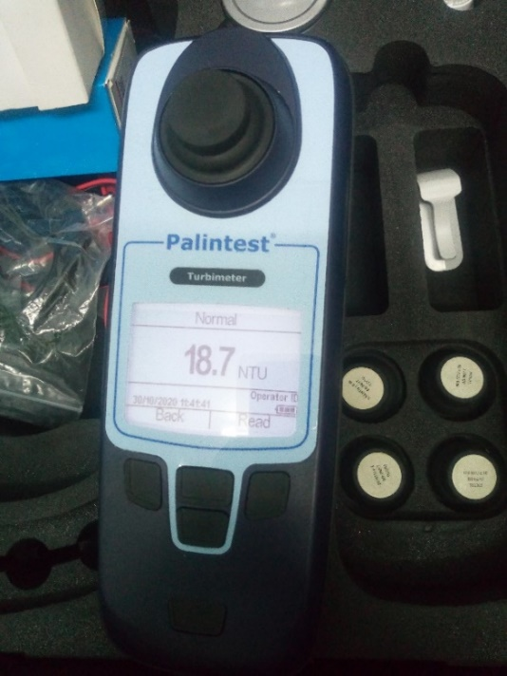 b)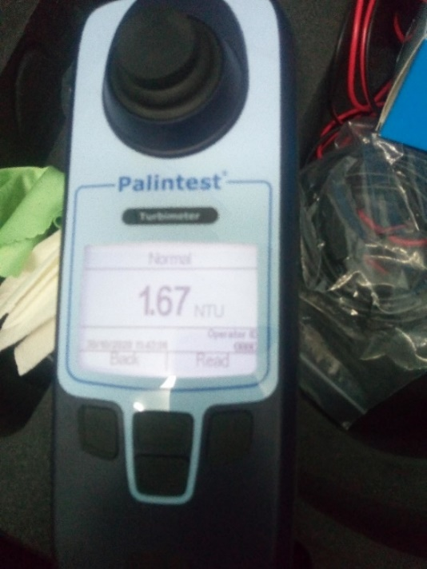

Figure 5‑10 image turbidity test of surface water a) before solar heating b) after solar heating

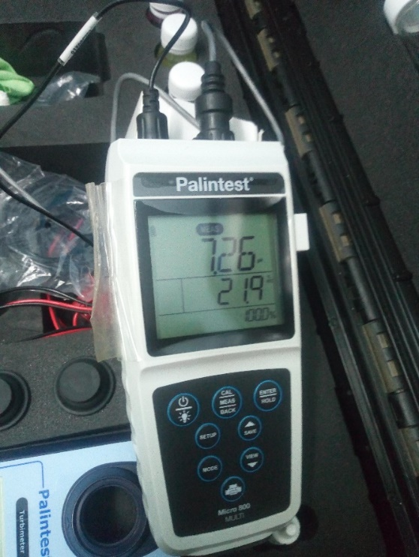b) 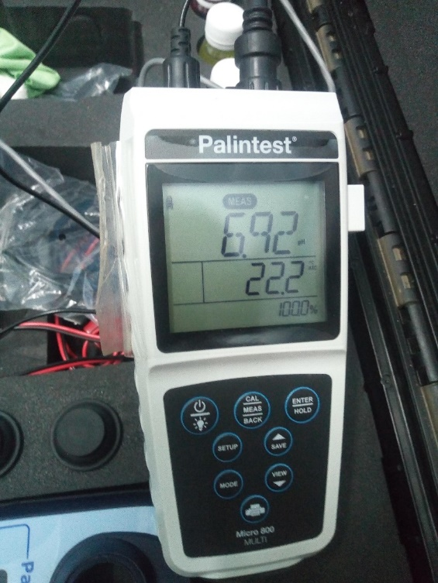

Figure 5‑11image PH and ATC test a) before solar heating b) after solar heating

a)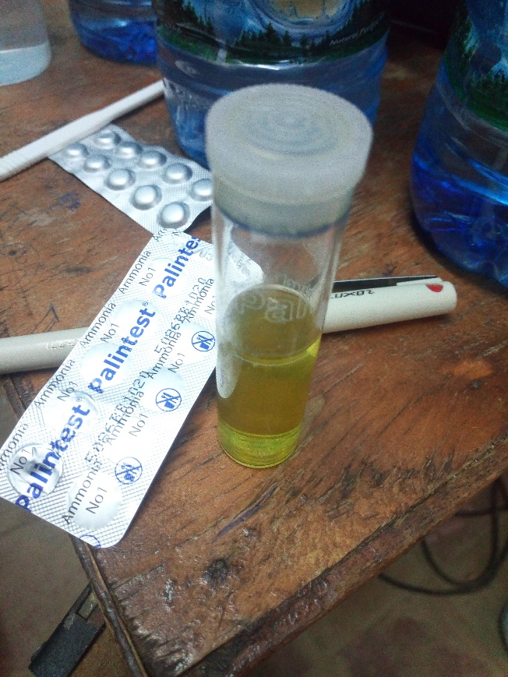 b)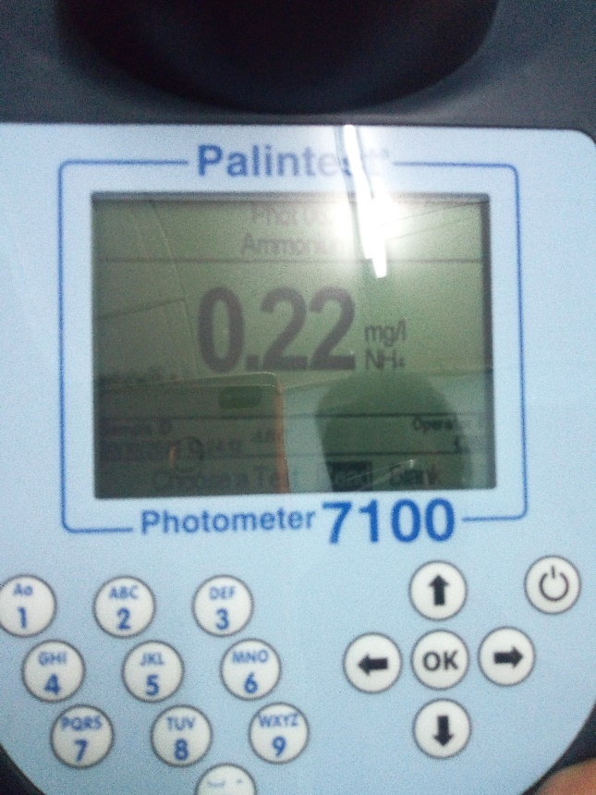

Figure 5‑12 image Ammonia test a) prepare reagent ammonia b) Ammonia concentration

## 5.7 Bacteriological tests

The test was conducted in Debretabor water utility center water quality test room and we have used two samples which are take each 100ml specimens and inserted each samples into bacteriologic test Machin Finally, after 18 hours we have seen the bacteria concentration on the litmus paper.

a) 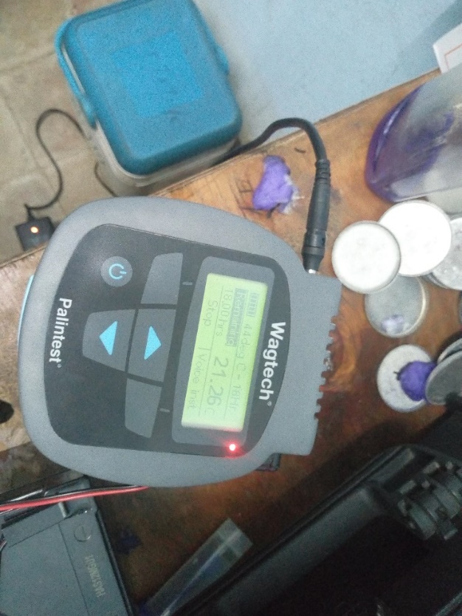 b)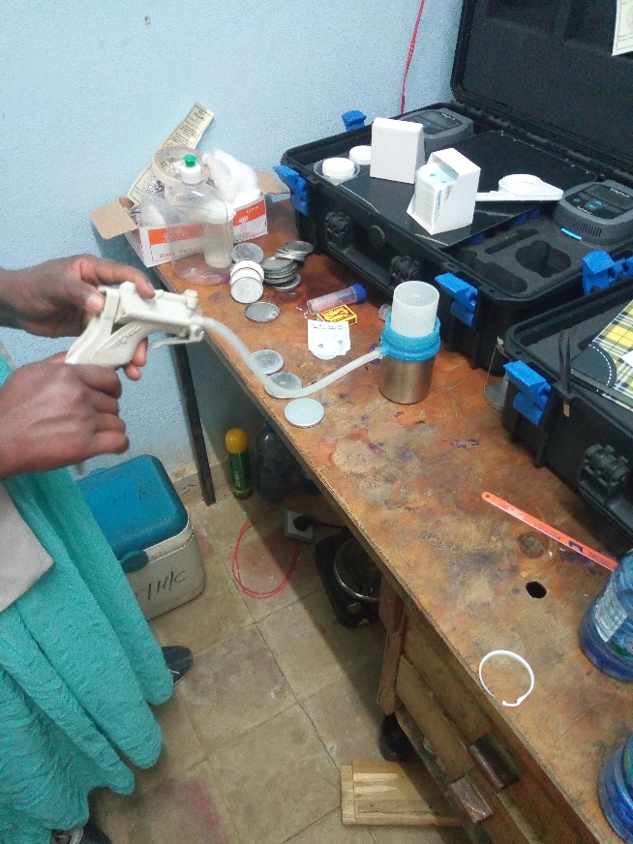

Figure 5‑13 image a) adjusted 18-hour b) preparation of water on microorganism test

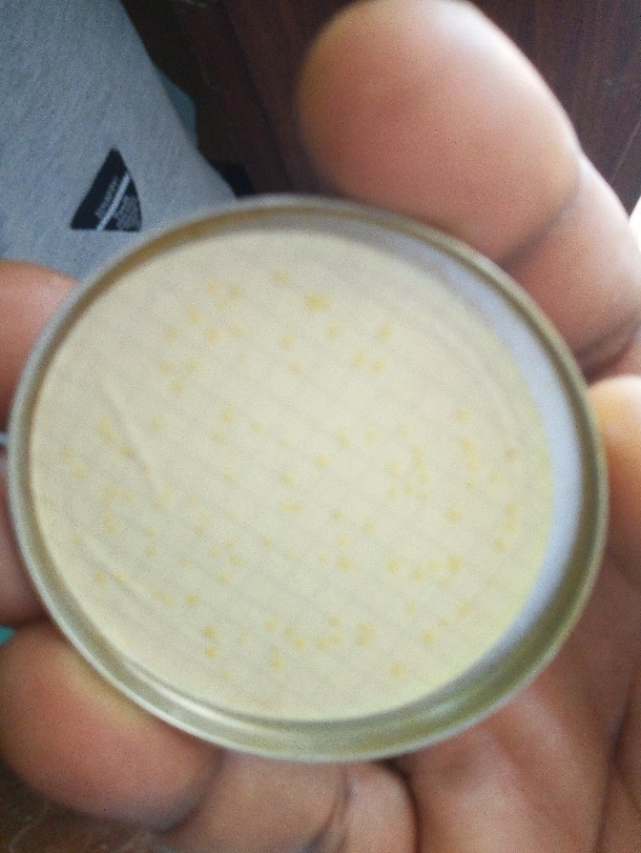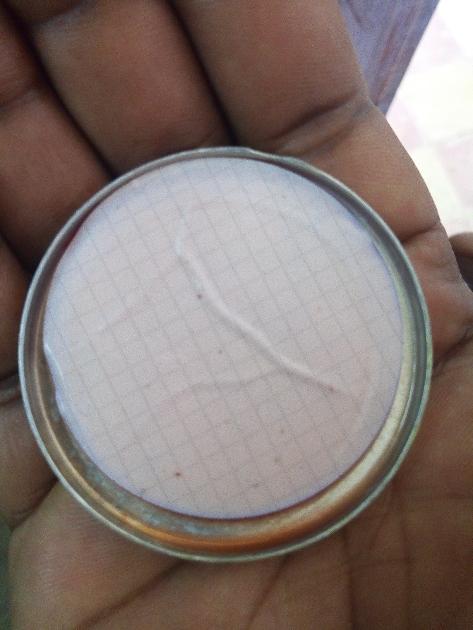

a) b)

Figure 5‑14 Photo a) Surface water before solar heating b) surface water after solar heating

As we have seen photo on litmus paper before solar heating bacteria and microorganisms has more concentrated and after solar heating, we have seen photo b there is no bacteria concentration which means we could kill the bacteria/microorganism boil the water at the temperature b/n 50-80 degree centigrade. Generally, disinfect bacteria concentrated in surface water using solar parabolic through solar collector.

Table 5‑2 physical and chemical composition of water before and after solar heating

|  |  |  |  |
| --- | --- | --- | --- |
| S,No | Parameters | Before | After |
| 1 | PH | 7-8 | 7-8 |
| 2 | Turbidity | 4-18.4NTU | 0.2-1.6NTU |
| 3 | Dissolve Oxygen | 5-6 mg/L | 4-5mg/L |
| 4 | Ammonia | 0.25mg/l | 0.22mg/l |
| 5 | Chloride | 57-58mg/L | 56-57 mg/L |
| 6 | Suspended solid | Not Visible | Not Visible |
| 7 | Micro-organism | More concentrated | No |
| 8 | Nitrates | 0.2mg/l | 0.5mg/l |

# 

# Reference

[1] Mogaji.P.B “Development of an improved pedal powered water pump”, IJSER, Vol 7, Issue 2, Feb-2016.

[2] Dr. S.Prakash, Deepak Toppo “Solar energy based water purification system”, IJPAM, Volume 119 No. 12 2018.

[3] Nikhil Jacob, Zachariah Vimal, P.Sunil Sachin and Tommy Vijith K “Design and fabrication of hand pump operated water purification system using reverse osmosis” IJIRST, Vol. 1, Issue 11, April 2015.

[4] Vishal Garg, Neelesh Khandare and Gautam Yadav “Design and experimental setup of pedal operated water pump”, IJERT, Vol. 2 Issue 1, January- 2013.

[1] J. Duffie and W. Beckman, Solar engineering of thermal processes, Fourth edition. john Wiley and, 2013.

[2] L. García-Rodríguez and C. Gómez-Camacho, “Preliminary design and cost analysis of a

solar distillation system,” Desalination, vol. 126, no. 1–3, pp. 109–114, Nov. 1999.

[3] S. Kalogeria, S. Lloyd, J. Ward, and P. Eleutherius, “Design and performance characteristics of a parabolic-trough solar-collector system,” Appl. Energy, vol. 11, no. 7, 1994.

[4] S. Kalogeria, “Parabolic trough collector system for low temperature steam generation: Design and performance characteristics,” Appl. Energy, vol. 55, no. 1, pp. 1–19, 1996.

[5] V. Dudley and G. Kolb, “Test results: SEGS LS-2solar collector,” NASA STI/Recon …, 1994.

[6] PWA, “Evaluation of Groundwater Part B Water Quality in the Gaza Strip Municipal Wells Water Resources Directorate,” 2013.

[7] D. J. Y. Alaydi, “The Solar Energy Potential of Gaza Strip,” Glob. J. Res. …, vol. 11, no. 7, 2011.

[8] “Palestinian Energy Authority.” [Online]. Available: http://pea-pal.tripod.com/. [Accessed: 20-Jun-2013].

[9] B. Norton, Solar Energy Thermal Technology, First Edit. Springer-Verlag London Ltd., 1992.

[10] S. Kalogirou, “Seawater desalination using renewable energy sources,” Prog. Energy Combust. Sci., vol. 31, no. 3, pp. 242–281, 2005.

[11] L. García-Rodríguez and C. Gómez-Camacho, “Preliminary design and cost analysis of a solar distillation system,” Desalination, vol. 126, no. 1–3, pp. 109–114, Nov. 1999.

[12] H. M. Qiblawey and F. Banat, “Solar thermal desalination technologies,” vol. 220, pp. 633–644, 2008.

[13] M. G. William Stine, “Power From The Sun.” [Online]. Available: http://www.powerfromthesun.net/. [Accessed: 30-Jun-2013].

[14] R. Foster, Solar Energy: Renewable Energy and the Environment, First Edit. CRC Press,

2009, p. 382.

[15] S.A. Esrey, R.G. Feachem, J.M. Hughes, Interventions for the control of diar-rhoeal diseases among young children: improving water supplies and excreta disposal facilities, Bull. World Health Organ. 63 (1985) 757–772.

[16] S.A. Estray, J.B. Potash, L. Roberts, C. Shiff, Effects of improved water supply and sanitation on ascariasis, diarrhea, dracunculiasis, hookworm infection, schistosomiasis, and trachoma, Bull. World Health Organ. 69 (1991) 609–621.

[17] T. Clasen, I. Roberts, T. Rabie, W. Schmidt, S. Cairn cross, Interventions to improve water quality for preventing diarrhea, Cochrane Database Syst. Rev.3 (2006) CD004794.

[18] L. Fewtrell, R.B. Kaufmann, D. Kay, W. Enanoria, L. Haller, J.M. Colford Jr.,Water, sanitation, and hygiene interventions to reduce diarrhea in less developed countries: a systematic review and meta-analysis, Lancet Infect.Dis. 5 (2005) 42–52.

[19] T. Clasen, S. Cairncross, L. Haller, J. Bartram, D. Walker, Cost-effectiveness of water quality interventions for preventing diarrhoeal disease in developing countries, J. Water Health 5 (2007) 599–608.

[20] P.S.M. Dunlop, M. Ciavola, L. Rizzo, J.A. Byrne, Inactivation and injury assess-ment of Escherichia coli during solar and photocatalytic disinfection in LDPE bags, Chemosphere 85 (2011) 1160–1166.

[21] D.C. Walker, S.V. Len, B. Sheehan, Development and evaluation of a reflec-tive solar disinfection pouch for treatment of drinking water, Appl. Environ. Microbiol. 70 (2004) 2545–2550.

[22] S.C. Kehoe, T.M. Joyce, P. Ibrahim, J.B. Gillespie, R.A. Shahar, K.G. McGuigan,Effect of agitation, turbidity, aluminium foil reflectors and container volume

# Appendix

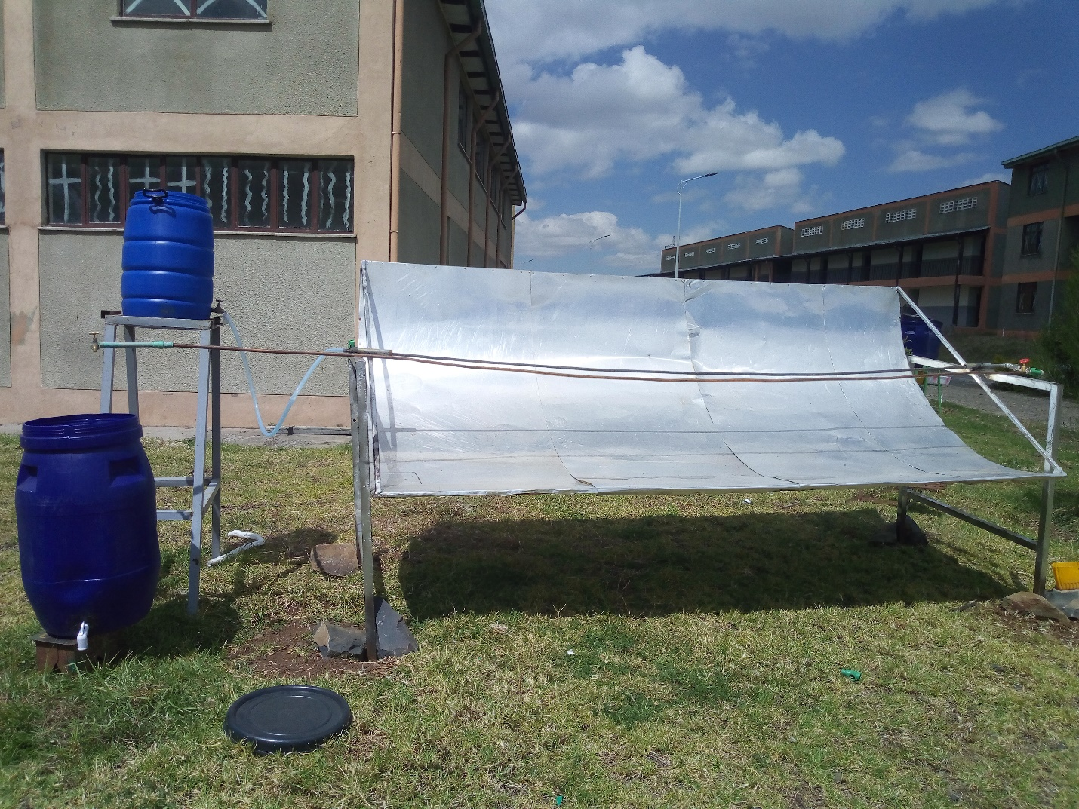

Figure A-1 solar purification system Thermosyphon system for circulating water

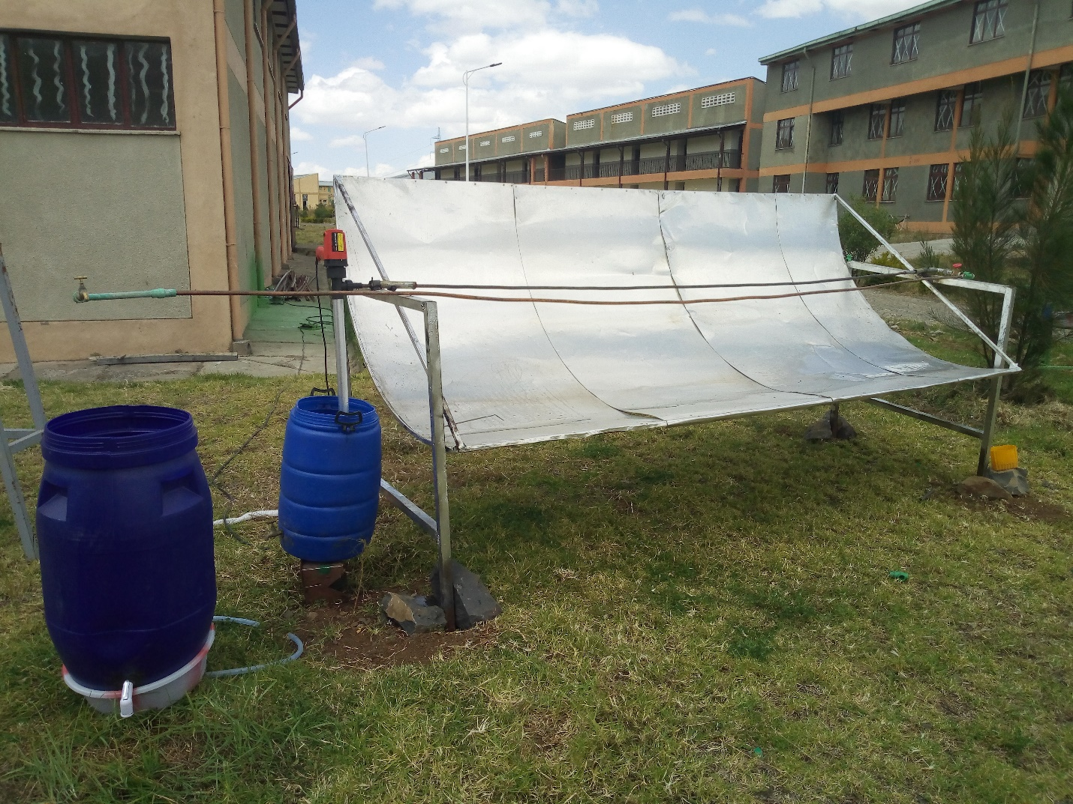

Fig A-2 solar purification system using pump for circulating

Table A‑1 experimental test water temperature on solar parabolic through

Oct 23/2020 Experiment 1

|  |  |  |
| --- | --- | --- |
| Time | Ambient temperature(00c) | Outlet temperature(00c) |
| 3:00 | 19 | 37 |
| 3:25 | 20 | 42 |
| 3:50 | 20.5 | 47 |
| 4:15 | 20.5 | 50 |
| 4:40 | 20.8 | 52 |
| 5:05 | 21 | 54.4 |
| 5:30 | 21 | 59.5 |
| 5:55 | 21.2 | 63.2 |
| 6:20 | 21.4 | 65.7 |
| 6:45 | 22.8 | 70 |
| 7:10 | 24 | 72 |
| 7:35 | 25.6 | 75.4 |
| 8:00 | 26 | 82.3 |
| 8:25 | 27.2 | 90.4 |
| 8:50 | 26.3 | 86.2 |
| 9:15 | 25.2 | 82.6 |
| 9:40 | 24 | 79.4 |

Table A‑2 experimental test water temperature on solar parabolic through

|  |
| --- |
| Oct 25/2020 Experiment 2 |

|  |  |  |
| --- | --- | --- |
| Time | T ambient(00c) | Toutlet(00c) |
| 3:45 | 19 | 30 |
| 4:10 | 20.1 | 38 |
| 4:35 | 20 | 43 |
| 5:00 | 20.3 | 54 |
| 5:25 | 20.8 | 61 |
| 5:50 | 21 | 65.3 |
| 6:15 | 21 | 66.3 |
| 6:40 | 21.8 | 68.4 |
| 7:05 | 22.6 | 71 |
| 7:30 | 23 | 76 |
| 7:55 | 23.1 | 82.4 |
| 8:20 | 23.5 | 88 |
| 8:45 | 22.4 | 84 |
| 9:10 | 22 | 81.5 |